**Pod LifeCycle**

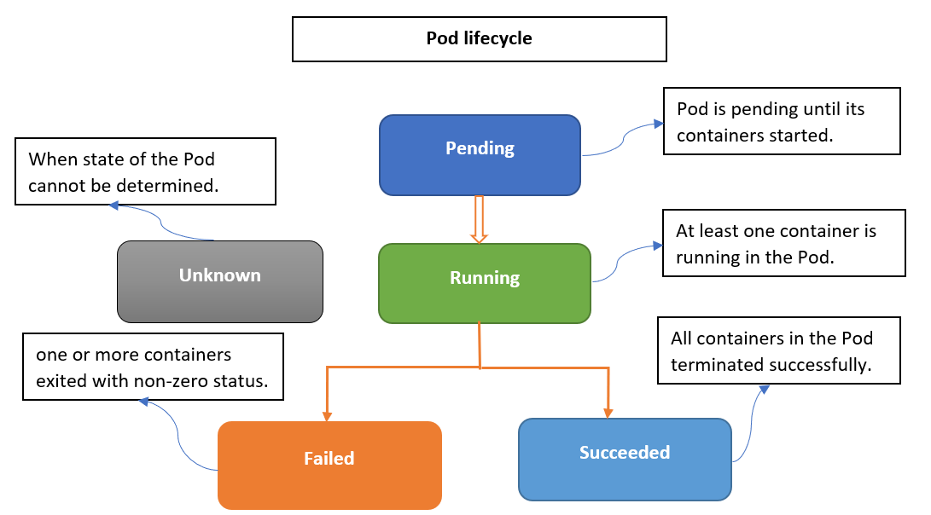

**1. Pending**

What’s Happening:

* You submit a pod manifest (e.g., kubectl apply -f pod.yaml)
* The Kube API Server accepts it and writes to etcd (Kubernetes database).
* Scheduler checks for available nodes with enough resources (CPU, RAM, taints/tolerations, affinity, etc.)
* Pending = Pod has been accepted but is not yet running on a node

**2. Running**

What’s Happening:

* The Scheduler assigns the pod to a node.
* The Kubelet on that node sees the assignment and:
  + Pulls container images (via container runtime like containerd)
  + Mounts volumes
  + Creates the pod sandbox (network namespace)
  + Starts containers
* Once at least one container is running, pod phase = Running

**3. Succeeded**

What’s Happening:

* All containers in the pod terminate successfully (exit code 0)
* Kubelet marks the pod as Succeeded
* Example: A batch job that processes a file and exits cleanly.

